COVID-19 Building Safety Plan
Medical Sciences Block C (MED C)
2176 Health Sciences Mall, Vancouver, BC

Contents
Introduction | 2
Reference Documents | 3
General Procedures | 3
Common Areas: | 4
Bathrooms | 4
Hallways | 4
Entrances / Exits | 4
Elevators | 5
Stairwells | 5
Meeting Rooms | 5
Kitchen / Lunch Room | 5
Handwashing / Sanitization Stations | 6
Custodial Services | 6
Workplace Activities: | 6
Direction of Travel | 6
Labs and Offices | 6
Sanitization of Surfaces | 7
Kitchen | 7
Meetings / Meeting Rooms | 7
Personal Protective Equipment (PPE) | 8
Communications Plan | 8
Compliance Monitoring | 8
Emergency Procedures | 9
APPENDIX 1 – MED C Building Room Occupancy Levels | 10
APPENDIX 2 – MED C Building Floor Plans | 11
APPENDIX 3 – Reporting Non-Compliance | 15
APPENDIX 4 – UBC Employee COVID-19 PPE Guidance | 17

Introduction
This Safety Plan for Medical Sciences Block C (MED C) was developed to provide guidance to faculty and staff to return to their laboratories and workspaces. It will allow our faculty to resume important research activities while abiding by physical distancing and safe practices. We expect compliance by everyone in our department and this means responsibilities for everyone, including PIs, staff and trainees. This plan is specifically intended to support activities under Phase 1 of the University’s Research Resumption process. It does not address the impact of Education re-entry in MED C, which will be dealt with under a separate process.

Medical Sciences Block C (MED C) is a 5 floor building that houses the Department of Anesthesiology, Pharmacology & Therapeutics (APT) on 4 of the buildings 5 floors. Laboratories and offices on the 1st floor are shared by faculty and staff from the School of Kinesiology and the School of Nursing. Common areas between APT and the occupants on the 1st floor are limited to the main entrance (south side of the building) and lobby, which serve as the main point of access and egress to the building. The elevators and stairwells in the building are primarily used by APT faculty, staff and students but may periodically be used by 1st floor occupants. The single person washroom on the 1st floor near the main lobby is open to all occupants in the building.

This COVID-19 Building Safety Plan will provide assistance for faculty and staff who need to provide some face-to-face instruction to ensure students meet the learning goals of their courses. This plan will include a review of Med Block “C” operational activities and directives to ensure effective controls are in place to prevent the infection from COVID-19. This document will be updated per government and / or University mandated requirements are changed. https://covid19.ubc.ca/

The prioritization guidelines of on-site activities are as follows:
- COVID-19 research
- Current research activity exemptions as approved previously (no new research or additional related activities).
- Clinical trials concurrent with clinical care
- Graduate students who need to be on-site to complete lab work for graduation as determined by the student’s Supervisory Committee for completion of thesis.
- Positions required to run core research facilities that are essential for approved on-site research.
- Upcoming time sensitive activities that cannot be done remotely and require on-site research access.
- Equity considerations for those that cannot work from home for various circumstances.
- Non-time sensitive activities that cannot be done remotely for limited access.

Requests to resume research at MED C will satisfy the priority requirements as set out by the Faculty of Medicine. The demand and need for on-site access is low. Due to ongoing COVID-19 research and other exempted activities, MED C has had ongoing occupancy during the curtailment period, of only 3 members who were covered under existing exemptions (approved by FoM). Under Phase 1, this will increase to 4.

Self-compliance with the guidelines set out in this document is of the utmost importance. Additionally, each unit is responsible for adhering to policies put in place by their Department, Faculty, and UBC. Failure to adhere to these policies increases the risk of an outbreak in our community, and lack of compliance could ultimately lead to closure of the facility.

The community is required to do their best to be flexible as we all adapt to new ways of operating. While we understand that some measures will be inconvenient, the health and safety of our community is priority number one.

Reference Documents:
The following guidance documents and resources on the Safety & Risk Services (SRS) COVID-19 Website were used in the development of this workspace plan:
https://srs.ubc.ca/covid-19/health-safety-covid-19/
- Prevention; Working Safely on Campus; Personal Protective Equipment; In-person meetings and training

General Procedures:
The following general procedures align with guidelines set by the BCCDC to prevent the spread of COVID-19.

Please describe how some or all of the methods below will be used in your lab:
- Before You Come to Work, monitor your health status.
If you are experiencing any of the common symptoms of COVID-19, complete the
BC COVID-19 Symptom Self-Assessment Tool, and call 811.
You must not come to work and must self-isolate
- Getting to Work: Private methods of transportation are preferred – visit parking.ubc.ca for parking information / rates. Where proximity allows, biking and walking should be encouraged as viable options. If you need to take transit, try your best to maintain social distancing at all times and follow hygiene recommendations (hand washing, use of hand sanitizer etc.).
- Individuals must always maintain a minimum distance of two metres (6 feet) between persons. This applies regardless of whether you are in an office, laboratory or any common or shared space. Work place traffic flows will be laid out using tape on the ground, in areas where there are multiple individuals occupying a workspace.
In hallways, to ensure social distancing, individuals will be required to walk on the right. Higher traffic areas will have signage posted as well as tape on the ground to indicate direction of traffic flows.
- If several people need to work in a shared space where social distancing can’t be reliably accommodated, the unit will need to establish a shift system.
- Internal handwashing stations are available on each floor. Building sanitization and bathrooms will be have a maintenance plan developed in collaboration with Custodial Services
- Sanitization of shared workspaces within research areas must be disinfected (with approved products) at the end of a shift, and at the start of a shift
- The use of Personal Protective Equipment (PPE, such as gloves and masks) other than PPE used for regular work duties and requirements – should be a matter of personal choice. How and why Personal Protective Equipment (PPE) should be used is referenced in Appendix 4.
- Individuals who require research specific training that cannot be completed while adhering to social distancing are not appropriate for inclusion in this phase of resumption. Volunteers (high school, undergraduate) will not be permitted at this time.
- Maximum number of people allowed at any one time in meeting rooms and internal common spaces (kitchens, printer rooms, waiting rooms etc.) is not to exceed 1 person (at a time)
- Use of Common areas (kitchen, foyer, bathroom, printer room, hallways etc.) is addressed under Common Areas (below). A COVID-19 Building Safety Plan for the Medical Sciences Block C building is posted in key locations throughout the building; provided to approved individuals by their faculty lead and available on the Department’s website at https://apt.med.ubc.ca/about/resources/
- Occupancy in any other common locations, such as classrooms and teaching labs are not included in this document and will be addressed separately as part of the Education Re-entry process

Common Areas:
The following common area safety practices must be followed:
Signage:
- COVID-19 signage provided by UBC Building Operations dealing with the directional flow on stairwells and individual floors; and occupancy levels in elevators, meeting/lunchroom, washrooms and shared common spaces will be posted to ensure social distancing is maintained. Reference to signage is further reinforced in various sections of this document.
Bathrooms:
- Occupants using washrooms must strictly adhere to social distancing requirements and stay more than 2 metres (6 feet) from one another.
- Multiple occupant-rated washrooms are restricted to a maximum of one occupant at one time.
- The shower on the first floor will remain available for use

Hallways:
- In hallways, to ensure social distancing, individuals will be required to walk on the right. If a hallway is not at least 2m wide, yield to oncoming traffic.

Entrances/Exits:
- Building entrances will remain locked 24/7.
- Users with programmed card access can enter the building via the main entrance (south side of the building) which is equipped with a card scanner. Do not let others enter behind you.
- Individuals entering the building through the north or west side of the building, will be doing so with a key. As you will be touching the doors, you should immediately wash your hands
Elevators:
- Elevators have been assigned maximum occupancy ratings (for MED C this has been set at 1 occupant only, based on elevator size) and corresponding signage has been posted at elevator doors on all levels. Whenever possible, use of elevators will be prioritized for those with accessibility needs or for transporting materials to prevent bottlenecks in the building.
- Occupants are not to exceed these temporary occupancy ratings and should immediately wash hands after exiting the elevator.
Stairwells:
- MED C has two stairwells, one on the east side of the building and one on the west side of the building. At this point, we have not designated these stairwells as “up only” or “down only”
- The east stairwell is at least 2m wide, so occupants are asked to walk on the right side both going up or down this stairwell
- The west stairwell is less than 2m wide, so occupants are asked to walk on the right, and yield to oncoming traffic in order to maintain social distancing
Meeting rooms:
- Meeting rooms are not to be used to hold meetings (such as lab meetings) but will remain available to occupants for eating lunches, etc.
- Occupants using the meeting room for lunch must strictly adhere to social distancing requirement and stay more than 2 metres (6 feet) from one another

Kitchen/Lunch rooms:
- These areas may not to be used to hold meetings but will remain available to occupants for eating lunches, etc.
- Occupants must strictly adhere to social distancing requirements and stay more than 2 metres (6 feet) from one another.
- Whenever possible, occupants are encouraged to bring food that is properly contained and ready to eat without the need for refrigeration, heating, or preparation in common kitchens.
- Wash hands before and after using any equipment. Bring your own cup and containers from home.
- No sharing of kitchen dishware/utensils unless an adequate means of sanitization (eg – dishwasher is available

Handwashing/Sanitizing Stations
- As per health authority recommendations, the best protection is washing hands with soap and water for 20 seconds at a time. All laboratories, kitchen areas, and washrooms are equipped with sinks and soap dispensers. Please wash your hands to protect yourself, and others, especially before and after touching surfaces that are difficult to sanitize or are frequently touched.
- A hand sanitizer dispensing station is located inside the main entrance on the 1st floor.
- During Phase 1, APT will have additional hand sanitization stations installed on both the basement and 2nd floors, in key high traffic areas on the floor.
- Custodial Services will refill these dispensers regularly. If you notice a dispenser is empty, you can note the time and location and advise Faid Saffou at 604.307-5520.

Custodial Services:
- Custodial Services continue to operate in the building at a reduced staffing level to keep the facility clean and sanitized in high traffic and high touch-point areas.
- If any building operations workers need to attend to your area, please vacate to ensure the safety needs of these workers can be met and that the building can be services appropriately

Workplace Activities:
The following safety practices must be followed:

Direction of Travel
- In spaces where one direction of travel can be assigned, assign a clockwise direction of travel using tape on floors for people to move around safely, otherwise practice walking on the right and yielding to oncoming traffic.

Labs & Offices
- Laboratory / research / office spaces may be assigned maximum occupancy ratings (based on COVID social distancing requirements).
- Assume maximum of 25% of the normal number of occupants can be present at any one time, based on dedicated workstations that are 2m apart throughout the space. Avoid workstation reassignment.
- For open workspaces, maintain 2m distancing and consider movement around the workspace.
- Single offices will count toward the 25% of normal occupancy in the space
- Shared offices – assume 1 person per shift unless the shared office is large enough to apply the 2m spacing.
- Occupants are not to exceed these designated occupancy ratings and must use administrative measures (such as scheduling) to maximize utilization of those spaces.
- Scheduling should be done at the local level, among the users of those particular spaces.
- Shared areas / rooms must be sanitized at the start, and at the end, of every usage period. See section on “Sanitization of surfaces”.

Sanitization of Surfaces
- Common areas and shared equipment that you touch must be cleaned and disinfected when you finish working. Additionally, clean and disinfect surfaces when you start your shift, or when visibly soiled.
- For research based applications, Public Health Agency of Canada’s biosecurity directive on SARS-CoV-2 lists disinfectants such as 10% bleach, 70% ethanol, 0.5% hydrogen peroxide, and phenolics as being effective. Consult SRS’s SOP on cleaning procedures for more information.
- Keyboard covers that allow spray-down are highly recommended to facilitate sanitization.
- Follow manufacturers’ guidelines for cleaning and sanitization of electronics and other specialized pieces of equipment.

Kitchen
- These areas may not to be used to hold meetings but will remain available to occupants for eating lunches, etc.
- Occupants must strictly adhere to social distancing requirements and stay more than 2 metres (6 feet) from one another.
- Whenever possible, occupants are encouraged to bring food that is properly contained and ready to eat without the need for refrigeration, heating, or preparation in common kitchens.
- Wash hands before and after using any equipment. Bring your own cup and containers from home.
- No sharing of kitchen dishware/utensils unless an adequate means of sanitization (eg – dishwasher is available

Meetings / Meeting Rooms
- According to University directives, face-to-face meetings are discouraged and should be avoided whenever possible (until post-pandemic normalization)
- In the majority of circumstances, virtual meetings should be arranged using the video-conferencing tools available through the University
- Meetings or training sessions deemed essential may need to occur. In such cases, social distancing requirements restrictions must be strictly observed. Please refer to https://riskmanagement.sites.olt.ubc.ca/files/2020/04/Guidelines-for-Meetings-Trainings-FINAL.pdf
- Meeting rooms are not to be used to hold meetings (such as lab meetings) but will remain available to occupants for eating lunches, etc.
- Occupants using the meeting room for lunch must strictly adhere to social distancing requirement and stay more than 2 metres (6 feet) from one another

Personal Protective Equipment (PPE)
- Personal protective equipment (PPE) has a role in preventing exposure to COVID-19 but must be combined with other measures to be effective. The University has produced official, university-wide guidance documents on the procurement and use of PPE during the COVID-19 pandemic.
- These resources are attached in Appendix 4.
- All university employees and contractors in Med Block “C” are to refer and adhere to these policies, standards, and practices.
- For students and instructors participating in approved in-person clinical skills coursework PPE will be provided and required as per public health guidelines and the UBC Faculty of Medicine.

Communications Plan
This document will be disseminated electronically to all staff and faculty working within the MED C building. The contents will be reviewed with individuals approved to return for in-person research activities during a meeting with the building administrator prior to the resumption of activities
Prior to returning to campus, all UBC community members will be required to complete an online training course (details to be provided as soon as available).
In addition, this safety plan, will be posted in key locations around the building and will be available on the Department’s website – www.apt.med.ubc.ca under COVID-19 Updates

Compliance Monitoring
According to University directives, monitoring of compliance with COVID safety plans will primarily be at the supervisor level, with any student activity in the building being monitored by relevant faculty and staff. COVID-19 remains a serious concern, requiring the sharing of responsibilities across the entire department and the involvement of the Faculty of Medicine Joint Occupational Health & Safety Committee (JOHSC) who have been involved in reviewing and contributing to the planning and processes outlined in this document. The specific responsibilities of the Dean of Medicine, the Executive Associate Dean, Research, the Department Head, the Principal Investigators, the Building Administrators and the JOHSC in ensuring compliance are outlined in the Faculty of Medicine Research Resumption Plan for Stage 1 – Ver 19. The MED C will continue to follow the university's accountability structure as laid out in the university safety policy.

Additionally, MED C occupants who have concerns about compliance, or have any related questions, can contact members of the MED C Safety Committee or Faid Saffou, APT Coordinator, Facilities and Information Technology. The process for reporting non-compliance can be found in Appendix 3.

Emergency Procedures
In the event of an emergency, standard MED C emergency procedures as laid out in the Building Emergency Response Plan (BERP) are to be followed, while adhering, as best as possible, to social distancing practices.
The MED C BERP can be found at: https://apt.med.ubc.ca/about/resources/

___________________________________________________________________________
I confirm that this Safety Plan has been shared with research personnel who will be accessing this space both through email and will be made available as a shared document. Staff can either provide a signature or email confirmation that they have received, read and understood the contents of the plan.

Date | June 25, 2020
Name (Manager or Supervisor) | Dr. Roanne Preston
Title | Department Head

MED C – Academic Unit Key contacts
Name Unit Administrator | Email & Phone #
Allison Rintoul  Admin Mgr, APT | allison.rintoul@ubc.ca / 604-363-8997
Faid Saffou  Coord, Facilities/IT - APT | faid.saffou@ubc.ca / 604-307-5520
Amy Kao  Admin Mgr., Kinesiology | amy.kao@ubc.ca / 604-822-2445
Ellen Siu  Mgr, Operations/Fin - Nursing | ellen.siu@ubc.ca / 604-822-7749

Faculty and Staff Occupying Work Space
Name | Email
Dr. Dmitri Petchkovski | petchkov@mail.ubc.ca
Dr. Ismail Laher | Ismail.laher@ubc.ca
Dr. Sastry Bhagavatula | sastry@mail.ubc.ca
Shweta Parmar | Shwetarockey.15@gmail.com

Appendix 1 – MED C Building Room Occupancy Levels:

Room / type of room | Department / Unit | Max Occupancy (Phase 1)
Wet Laboratory | Bernatchez | 2
 | Bhagavatula | 2
Dry Laboratory |  | 0
Offices | Laher | 1
 | Bhagavatula | 1
Shared Rooms
Workshop |  | 1
Equipment Work Room |  | 1
Teaching Lab |  | 0
Teaching Prep Room |  | 0
Storage |  | 0
Specimen Holding |  | 0
Specimen Storage |  | 1
Specimen Procedure |  | 1
Instrument Room |  | 0
Freezer / Cold Room |  | 1
Dark Room |  | 0
Autoclave Room |  | 1
Common Rooms
Photocopy Room |  | 1
Seminar / Conference / Lunch Room |  | 1 to 2, based on social distancing
File Room |  | 0
Storage Room |  | 0
Washrooms |  | 1
Elevator |  | 1
Appendix 2- MED C Building Floor Plans 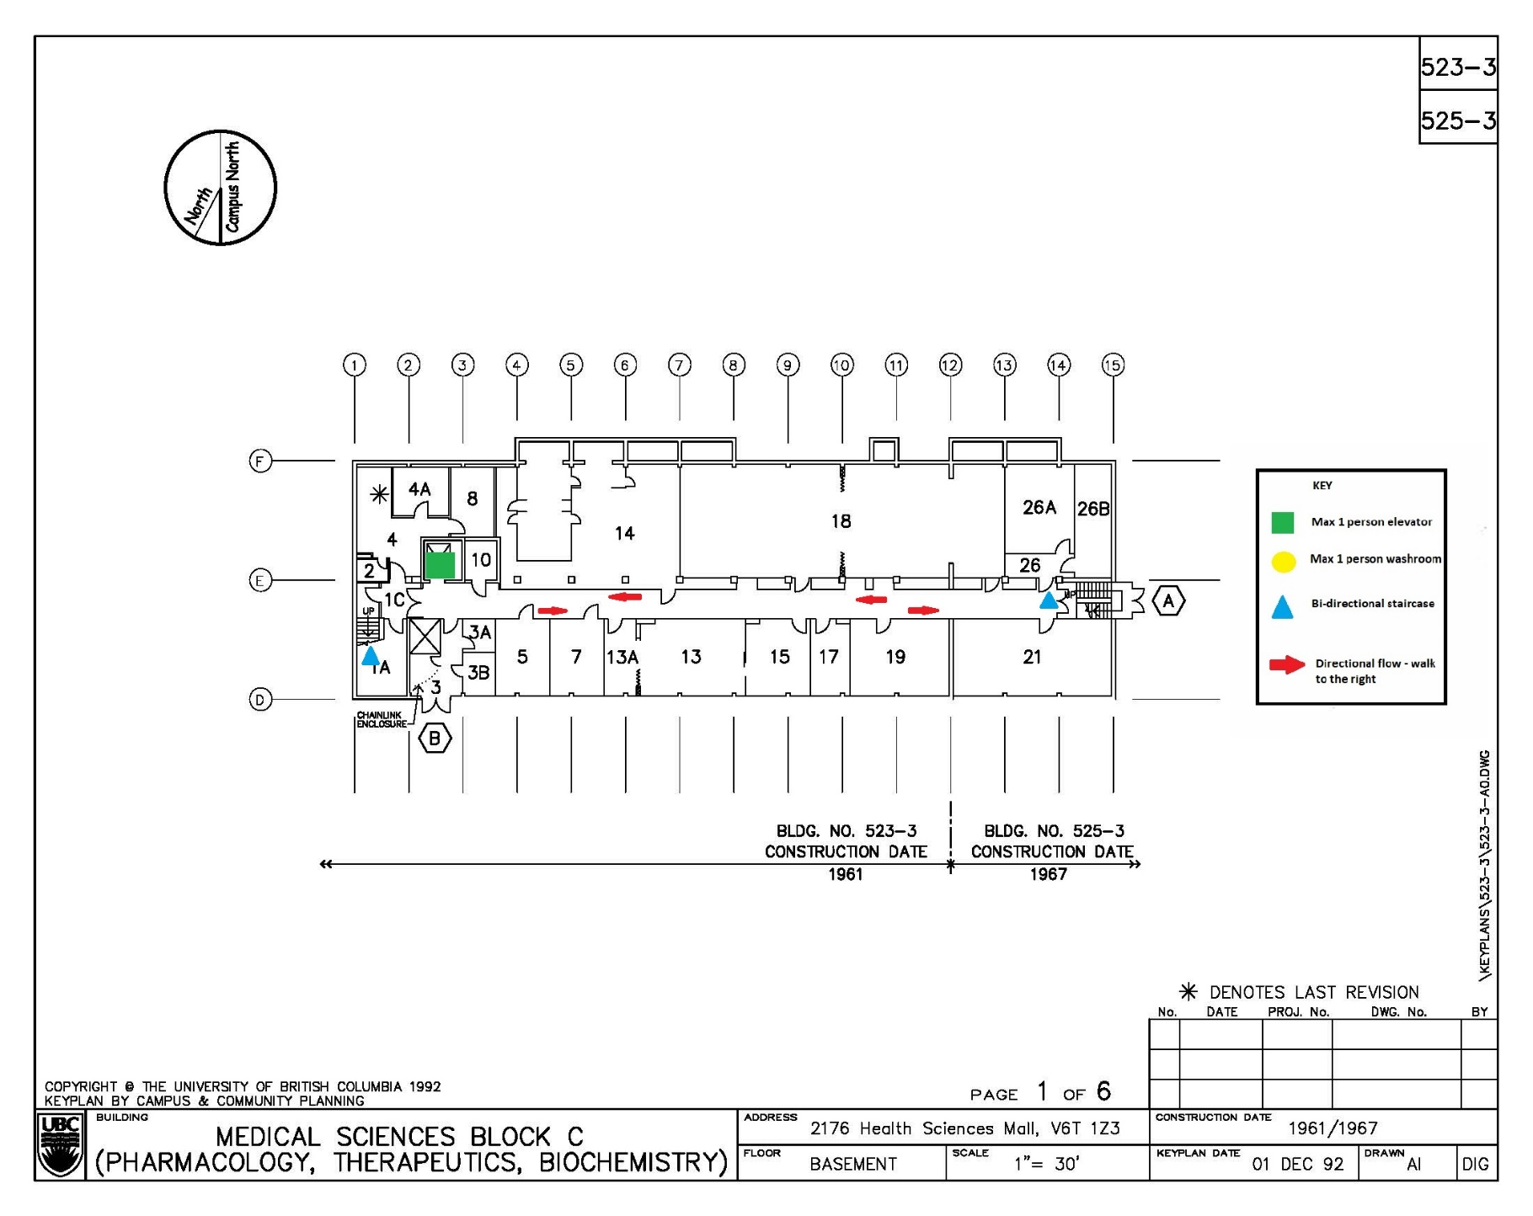

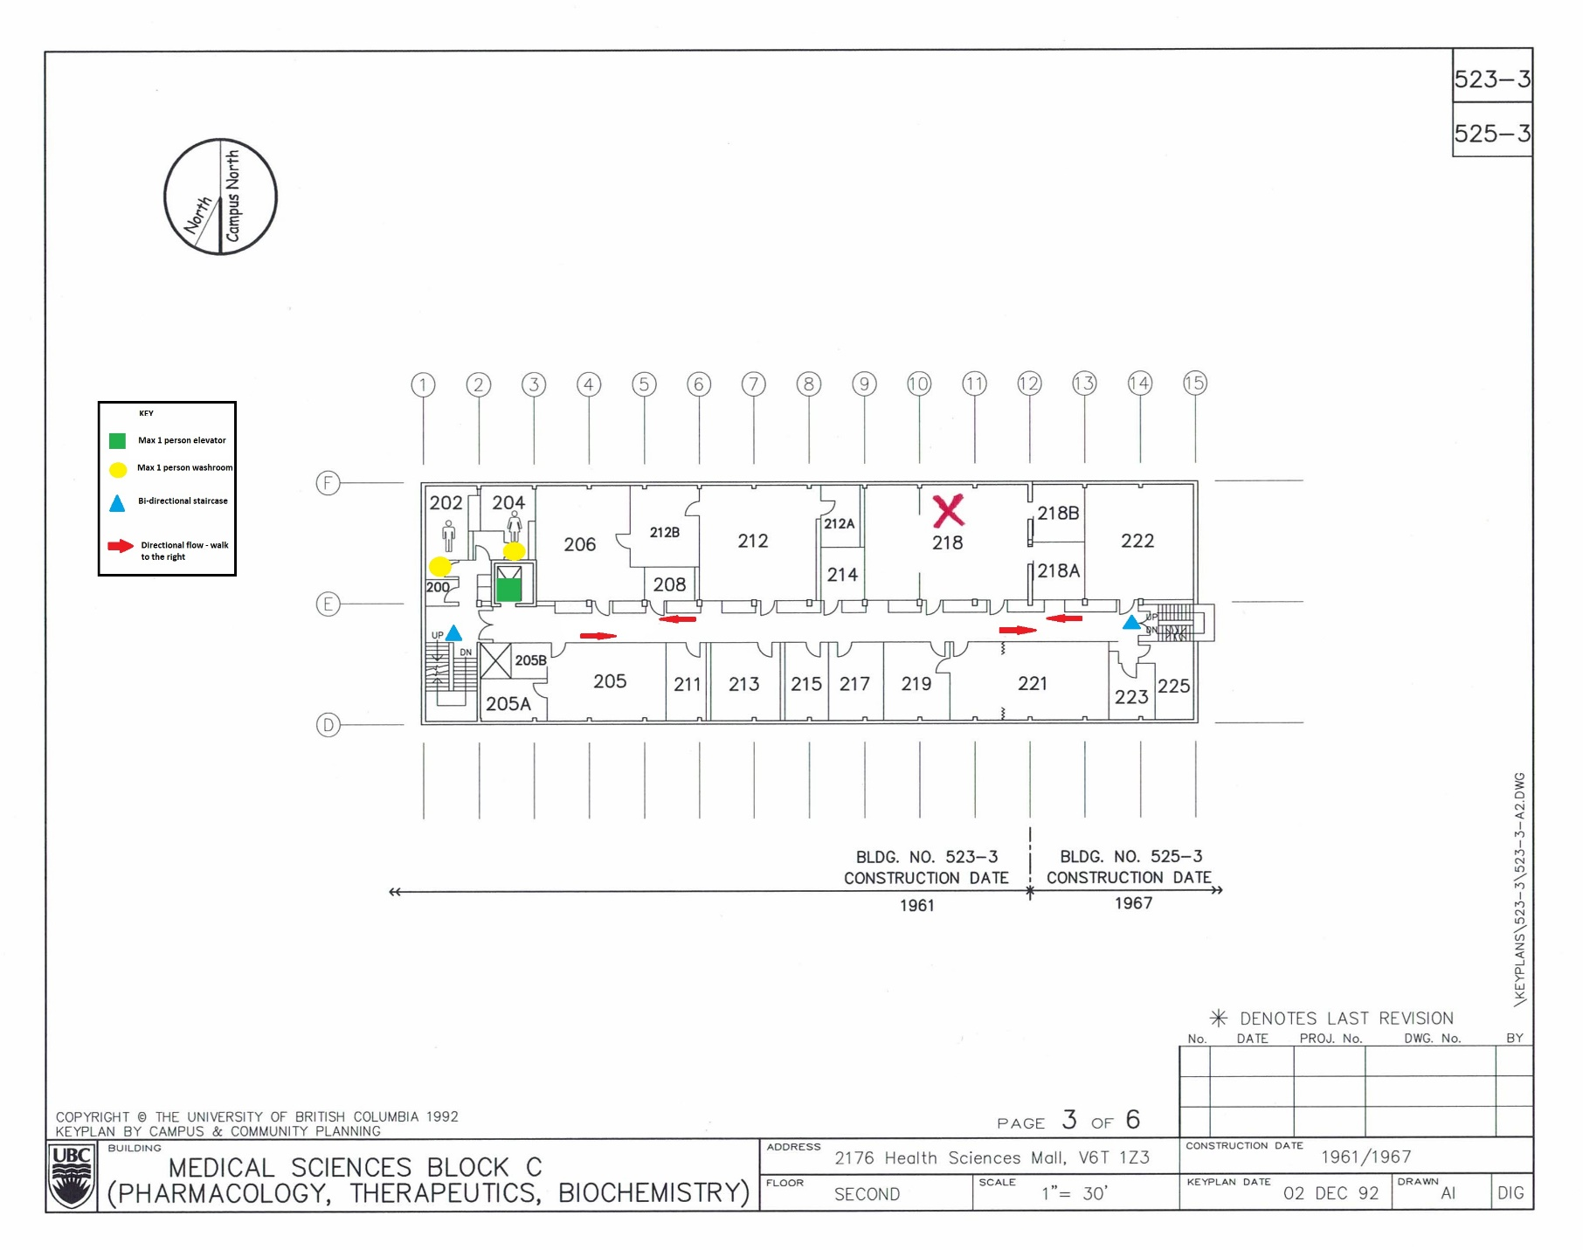

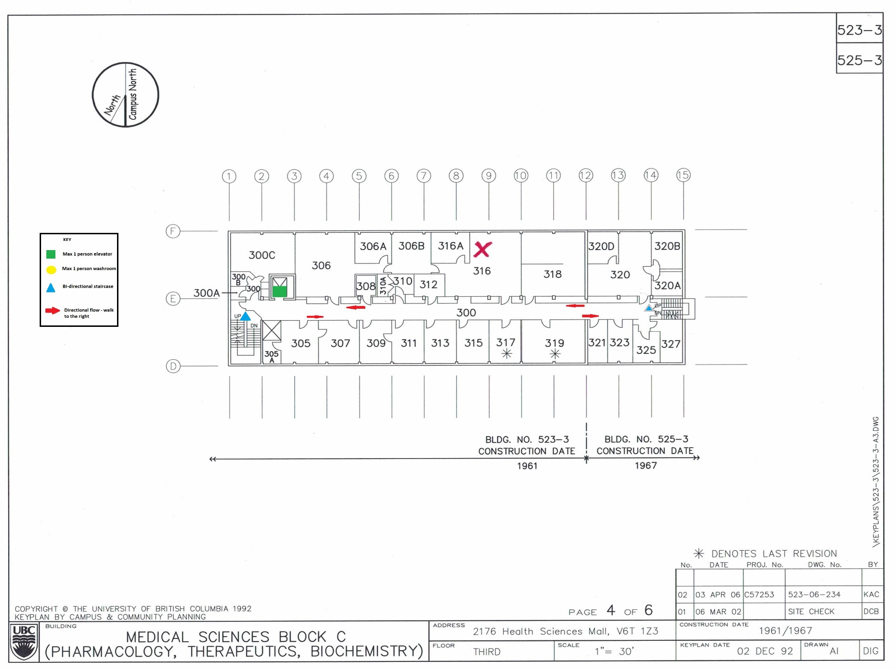

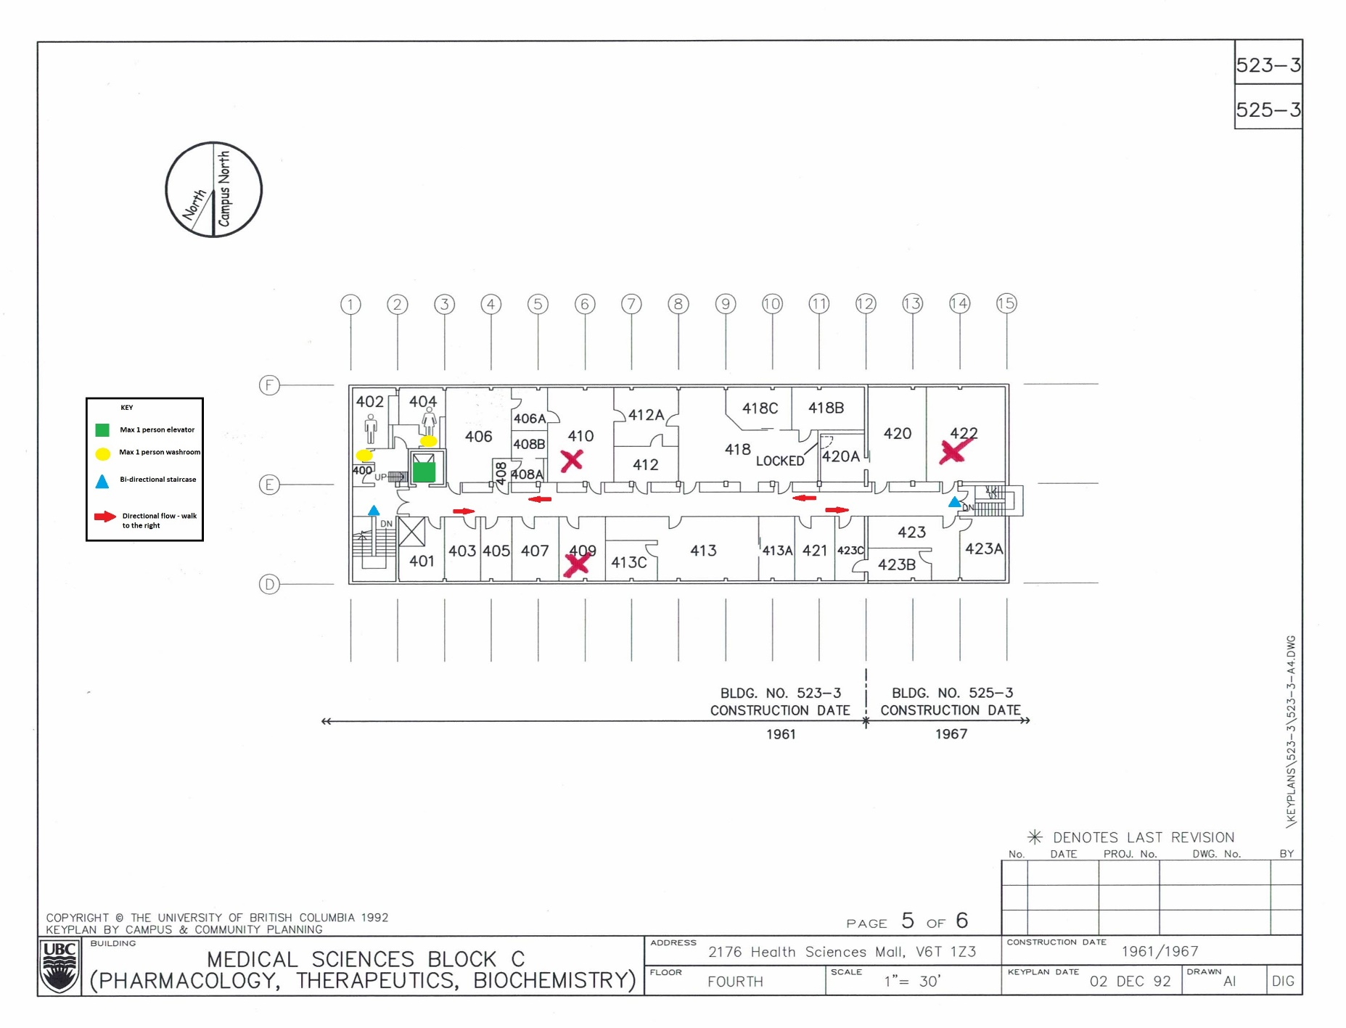
Appendix 3- Reporting Non-Compliance
The resumption of research activity at UBC will be managed in phases, which have been developed and articulated in close collaboration with faculty members, Deans, the UBC Executive, and other. To resume research activity successfully will require a commitment from the community to the principles and plans that the University has established:
- The health and well-being of faculty , students and staff is paramount
- The orders, notices and guidance of the Provincial Health officer will be followed
- Permission to conduct on-campus research and scholarship will be limited to those who require on-site resources and cannot work remotely
- There will be a phased and coordinated approach across each campus
- Phased resumption of activity may need to be reversed and stricter curtailment conditions imposed in response to public health guidance or changes to the situation on our campuses
- If an individual has a concern about returning to work, they will have an opportunity to discuss that with their supervisor, Human Resources, and their employee group as appropriate
- Equity will be considered in evaluating how to plan and conduct research resumption

Faculty and PI Level plans for resuming research activity will reflect these principles, and will account for relevant safety protocols. There will be common protocols around handwashing and physical distancing, building specific protocols for cleaning, and unique protocols for individual labs and other spaces. It is of paramount importance that all community members involved in on-campus research activities, comply with these safety protocols at all times. It is equally important to understand that failure to comply with these protocols may result in access permissions being withdrawn, may present a risk to the health and wellbeing of our people, and could ultimately lead to discipline.
Individual PIs are responsible for the health and safety of personnel working in their labs. Academic Heads of Units are responsible for the health and safety of everyone who reports to them, and also responsible for ensuring that everyone in the Unit is adequately supervised. The supervisor – the PI or the Administrative Head of Unit – is responsible for investigating any complaints of non-compliance with a specific safety protocol, non-compliance with the guiding principles above or non-compliance with guidance form the Provincial Health Officer. For support in investigating incidents of non-compliance or similar concerns, Administrative Heads of Unit or the Principal Investigator can contact their Human Resources Advisor or Faculty Relations Senior Manager.
REPORTING NON-COMPLIANCE
Circumstance may occur where there is a perception of non-compliance, when in fact that is not the case. An example would be two work colleagues who live in the same home who are seen to be working less than six-feet apart from one another. In most cases, a quick discussion with the individuals involved may help to resolve any concern.
Where clear non-compliance with safety protocols is clearly occurring, it is important to understand that this reporting procedure is mandatory:
- Non-compliance with a safety protocol within a lab/research space is first reported to the Principal Investigator. Non-compliance on the part of a PI is frist reported to the Administrative Head of Unit (department head)
- The Principal Investigator (or Head of Unit) must investigator the situation without delay by contacting the appropriate people in the lab or other space. This could be research staff, trainees, or the PI. The may also seek advice from UBC Safety & Risk Services.
- As part of the investigation, it may be advisable, though not always feasible, to do visual inspection of the lab/research space in question.
- If a claim about non-compliance is substantiated, the supervisor (PI or Head of Unit) will consult with Human Resources, Faculty Relations, Safety & Risk Services, and other units to determine an appropriate response. The response could include:
- Suspension of access to on-campus facilities
- Curtailment of the type or location of activity that can be undertaken on campus;
- Depending on the nature and severity of the non-compliance, suspension or other employment-related discipline
- Resumption of activity can only occur with the agreement of the supervisor who investigated the complaint, and only when that person is satisfied that the conditions leading to the non-compliance have been resolved.
Supervisors are expected to share this document with their teams, to ensure everyone involved in resuming research activity is aware of the importance of respecting the safety protocols put in place, of the mechanism for investigating complaints, and of the potential consequences for non-compliance.

Appendix 4- UBC Employee COVID-19 PPE Guidance

Overview
This document provides guidance about UBC’s stance on employee Personal Protective Equipment (PPE), including industry standard face masks/respirators, gloves, homemade and non-surgical masks and other PPE in relation to COVID-19 and other infectious diseases.

Visit ubc.ca/covid19 for more information about UBC’s response to COVID-19, including frequently asked questions.

Current health guidance relating to PPE
Throughout the current COVID-19 global outbreak UBC has taken direction on infection prevention from the Provincial Health Officer, the BC Centre for Disease Control (BCCDC) and Vancouver Coastal Health (VCH), and continues to do so. This guidance can be expected to evolve as these agencies continually monitor accumulating scientific evidence to determine how we can best prevent the spread of COVID-19.

As this document has been developed, the current health guidance from the above agencies can be summarized as follows:
- Incorrect selection and/or use of PPE may increase your risk of exposure.
- Using non-medical or homemade protective equipment does not diminish the need for physical distancing, frequent hand washing and avoiding touching your face.
- There is no established proof that wearing non-medical or homemade protective equipment protects the person wearing it, and it may provide a false sense of security.
- Wearing a non-medical mask in public may help to limit the travel of your respiratory droplets when you cough, sneeze or talk - which may help to protect others.
- Medical /surgical masks should be used by people who are sick and health care workers.
- N95 Respirators, Medical masks and other critical PPE are in short supply and are needed by health care workers to safely care for their patients.

Personal Protective Equipment in the workplace
Based on the above medical guidance and circumstances on our campuses, UBC’s position on PPE is as follows:
- UBC employees carrying out tasks that require PPE, including respirators, will continue to be supplied with the appropriate equipment, as per the relevant safe working procedure.
- UBC employees carrying out tasks that do not normally require PPE will not be supplied with masks or respirators of any description.
- UBC will not provide employees with non-medical or homemade masks as these masks do not meet the performance standards for workplace PPE and do not satisfy the safety requirements of any work task.
- UBC employees may wear a non-medical mask or homemade mask at work, provided it does not interfere with them safely carrying out their duties.
- UBC asks the campus community to be respectful of students, faculty and staff who choose to wear masks.

The role of PPE in protecting employees

PPE is used to protect employees from specific risks, however it is the least effective method of protecting employees, as outlined in the below Hierarchy of Controls diagram. The diagram also includes examples of current UBC COVID-19 risk mitigation activities.

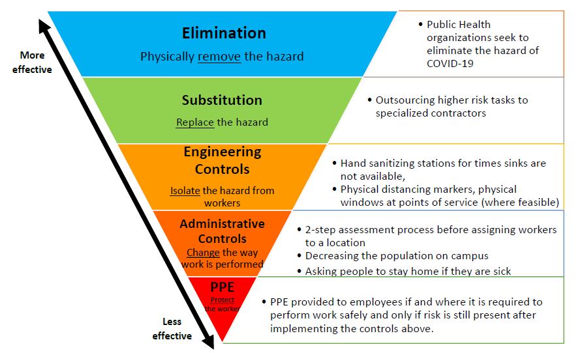

Respirators & Masks
Respirators are one type of PPE, and conditions of their usage for workplace safety is closely regulated by WorkSafeBC. To be effective, all respirators used must be fitted to an individual’s face through a fit test.
Health care workers may be directed to wear either N95 Respirators or Medical/ Surgical Masks as part of their PPE for specific tasks and under the regulations as they pertain to health care settings.
Supply shortages in N95 respirators have prompted the assessment of KN95 respirators as an alternative to address particulate respiratory hazards. However, KN95 masks have been deemed inappropriate for occupational use at UBC due to the inability to properly fit test them and lack of vendor clarity around manufacturing standards. Any KN95 masks received as donations cannot be issued to UBC Employees.

Gloves
There are many types of gloves, and the choice of glove must take into account all of the hazards that may be present, as gloves are rated for their usefulness as a barrier to different types of chemicals. Medical gloves create a barrier around the hands to reduce an individual’s risk of exposure to hazardous agents.
This type of PPE can be used during infectious outbreaks but must be used carefully to avoid transferring contamination between the handling of infected and clean items. Personal electronics, high touch surfaces and other shared items are prone to this ‘cross contamination.’

Eye & Face Protection
Eye protection, through safety glasses or goggles, and face shields are recommended for health care workers where there is the potential for any spraying or splattering of blood or other bodily fluids. Safety glasses can be found in various different styles and offer side protection in the form of either wraparound arms or shields. Goggles offer a higher degree of spray/splatter protection compared to safety glasses due to their ability to form a tight seal around the eyes. Face shields can protect the entire face from biological hazards. A face shield is often considered a secondary safeguard to protective eyewear. In other words, face shields are typically not used on their own. As per WorkSafeBC requirements, these types of PPE need to meet CSA Standards.

Information about using non-medical or homemade protective equipment
Non-medical/homemade masks are not classed as Personal Protective Equipment. UBC does not endorse the use of non-medical or homemade masks.
UBC will only supply Personal Protective Equipment that meet applicable standards and as required for UBC work.
If you are considering using a non-medical or homemade mask, you can find information about how to do so safely on the BC Centre of Disease Control website.

Advice on PPE at UBC
If you have any questions or require advice about PPE at UBC, or if you need to widely communicate information in this document, please contact Safety & Risk Services by emailing ready.ubc@ubc.ca
.

Regarding the use of non-medical and homemade masks while at work at UBC during COVID

The University is following the guidance of the BC CDC and Public Health Officer on prevention of COVID19 by implementing:
• Physical distancing wherever feasible including scheduling of personnel to allow for physical distancing • Engineering controls such as barriers at points of service
• PPE where appropriate
The use of non-medical masks, including re-usable cloth masks by healthy people in the university community carries the following limitations and risks:

Limitations
• Non-medical masks do not protect the person wearing it, and are not PPE.
• Their effectiveness in containing of the droplets expelled during breathing, talking, laughing, sneezing or coughing is limited and highly variable.
• Depending upon the positioning of the individuals in close proximity to each other, these masks may or may not reduce the droplets expelled by each worker into the breathing zone of the other.
• Non-medical masks are not equivalent to respirators, and do not override the needs for physical distancing, good hygiene, and staying home when ill.
• Non-medical masks become less effective if soiled or damp, so must be changed and laundered frequently and routinely.

Risks
• Self-contamination that can occur by touching and reusing contaminated mask, especially in worksites where allergens, chemicals or other hazardous materials are present and can be absorbed onto mask material
• Potential breathing difficulties
• False sense of security, leading to potentially less adherence to other preventive measures such as physical distancing and hand hygiene
• Not a measure to protect others if the wearer has symptoms or is ill.

UBC employees may choose to wear a non-medical mask or homemade mask at work, provided it does not interfere with them safely carrying out their duties. UBC asks the campus community to be respectful of students, faculty, and staff who choose to wear masks. SRS is currently not recommending the use of homemade or non-medical masks in the workplace. If a unit within the LSC decides to proceed with providing masks to their employees, the recipients must be aware of the limitations and risks outlined above and acknowledge receipt of the information. Our goal is to continue to recommend physical distancing, as we know that is the best method to reduce the risk of transmission.

Additional, up-to-date UBC-COVID resources are found at:

- https://covid19.ubc.ca/

- https://srs.ubc.ca/health-safety/health-safety-covid-19/

