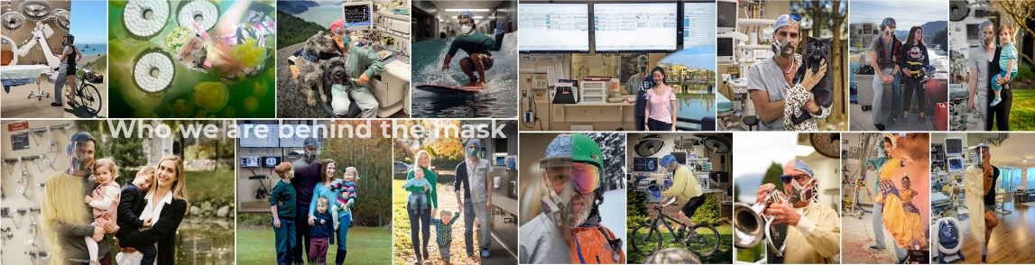
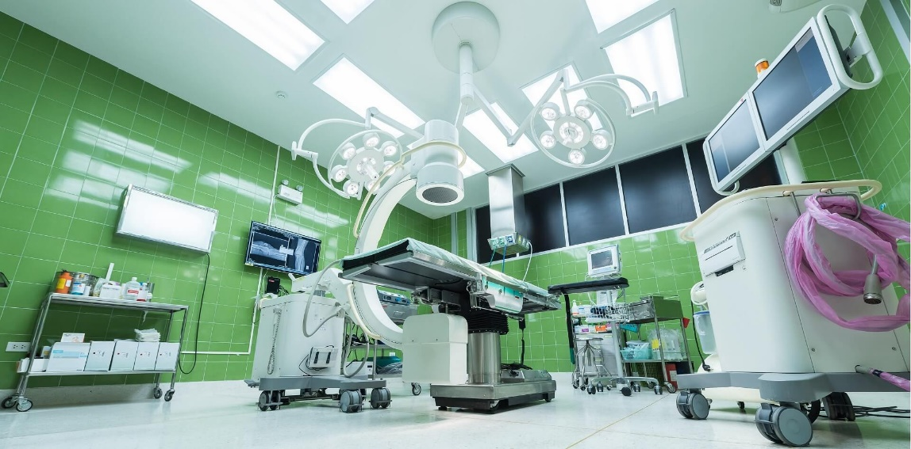
16th Annual
APT Research Day
May 26, 2022

Welcome to APT Research Day!

On behalf of the organizing committee and Dr. Preston, we welcome you to the 2022, 16th Annual APT Research Day. We are very excited to back in person, live from St. Paul’s hospital, while broadcasting online, and look forward to a day of excellent presentations and discussion! We are especially grateful and honored to welcome a special guest - Dr. Hance Clarke, from the University of Toronto, who will be delivering the Hugill lecture. We are also very excited to introduce a new lecture category, which is intended to showcase the exciting growth of the Department – thank you to Dr. Catrina Loucks for delivering the inaugural “Emerging Faculty” lecture.
The 2022 meeting sees the return of the “lightening talks”, as well as invited oral presentations from trainees. Further recognizing the major research accomplishments from Faculty members in the last year, we will also announce our winners for paper of the year!
A few reminders – if you are joining online, please be sure to mute your microphone during presentations. If you are online and have a question, please raise your hand and the moderator will unmute you when ready. If you are in the room…channel the days before COVID and make yourself known to a moderator!
Finally, we would like to thank all the judges that assisted in reviewing abstracts and papers of the year, as well as those judging oral presentations today – this day is better because of you! Also, a special thank you to Faid Saffou and Aileen Chiu for technical and administrative support.
We hope that you enjoy the day, learn something new, and leave a better researcher!
Regards,

Alana Flexman, Don Griesdale, John Kramer, Stephan Schwarz

SCHEDULE
10:00 – 10:30 | Room set-up & upload talks
10:30 – 11:00 | Welcoming Remarks and Land Acknowledgement  Dr. Roanne Preston  Professor and Head, Department of Anesthesiology, Pharmacology & Therapeutics
11:00 – 12:35 | First Session
10 min | Rotational Thromboelastometry (ROTEM) Guided Use of Factor Concentrates in Cardiac Transplant Patients: A Retrospective Study  Dr. Kimberly Li (Ree)
10 min | Postural dependent resting brain activity does not influence laser evoked potentials  Dr. Lukas Linde (Kramer)
10 min | Development of a tool to communicate postoperative pain risks of children to families – results of a second round of clinician and family co-design  Dr. Christina Fokkens (Görges)
10 min | Promising pain relief? Evaluating PROMIS-29 questionnaires during a trial for spinal cord stimulation treatment in patients with neuropathic pain  Dr. Bergeron-Vitez (Kramer & Varshney)
25 min | Lightning Talks – session 1
30 min | Exploring the genetic basis of heterogeneous drug responses to enhance pain management in vulnerable populations  Dr. Catrina Loucks  Emerging Faculty Invited Lecturer
12:35 – 13:10 | Lunch break
13:20 – 14:20 | Second Session
10 min | Is a change in end-tidal carbon dioxide concentration associated with hypotension during periods of general anesthesia with stable mechanical ventilation? Analysis of a large cohort.  Dr. Vanessa Giesbrecht (Missirlis)
10 min | Effect of cigarette smoke exposure on airway epithelial barrier function in never-smokers and ex-smokers with and without COPD  Dr. Kinglsey Okechukwu Nwozor (Hackett)
20 min | Lightning Talks – session 2
10 min | A new hypertonic saline assay for analgesic screening in mice: effects of animal strain, sex, and diurnal phase  Dr. Bernard MacLeod
10 min | Rationalized preoperative management of hip and knee arthroplasty patients: A retrospective cohort study  Dr. Jacqueline Trudeau
14:20 – 14:35 | Coffee Break
14:35 – 14:45 | Award Presentation
14:45 – 15:45 | The future of Canadian Pain Care: The value of Transitional Pain Services and the evolution medical cannabis  Dr. Hance Clarke  Dr. Jean Templeton Hugill Memorial Lecturer
15:45 | Closing Remarks

LOCATION
In Person | Cullen Family Lecture Theater  St. Paul’s Hospital  For detailed info on how to get here, LINK  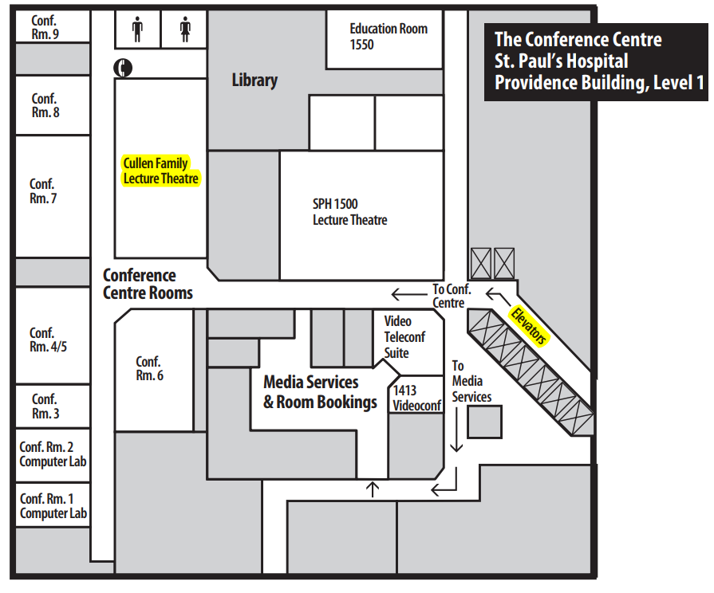
Zoom | https://ubc.zoom.us/  Meeting ID: 95272 854360  Passcode: 854360

Slido for Lightning Talks – www.sli.do
Code: 7866482

